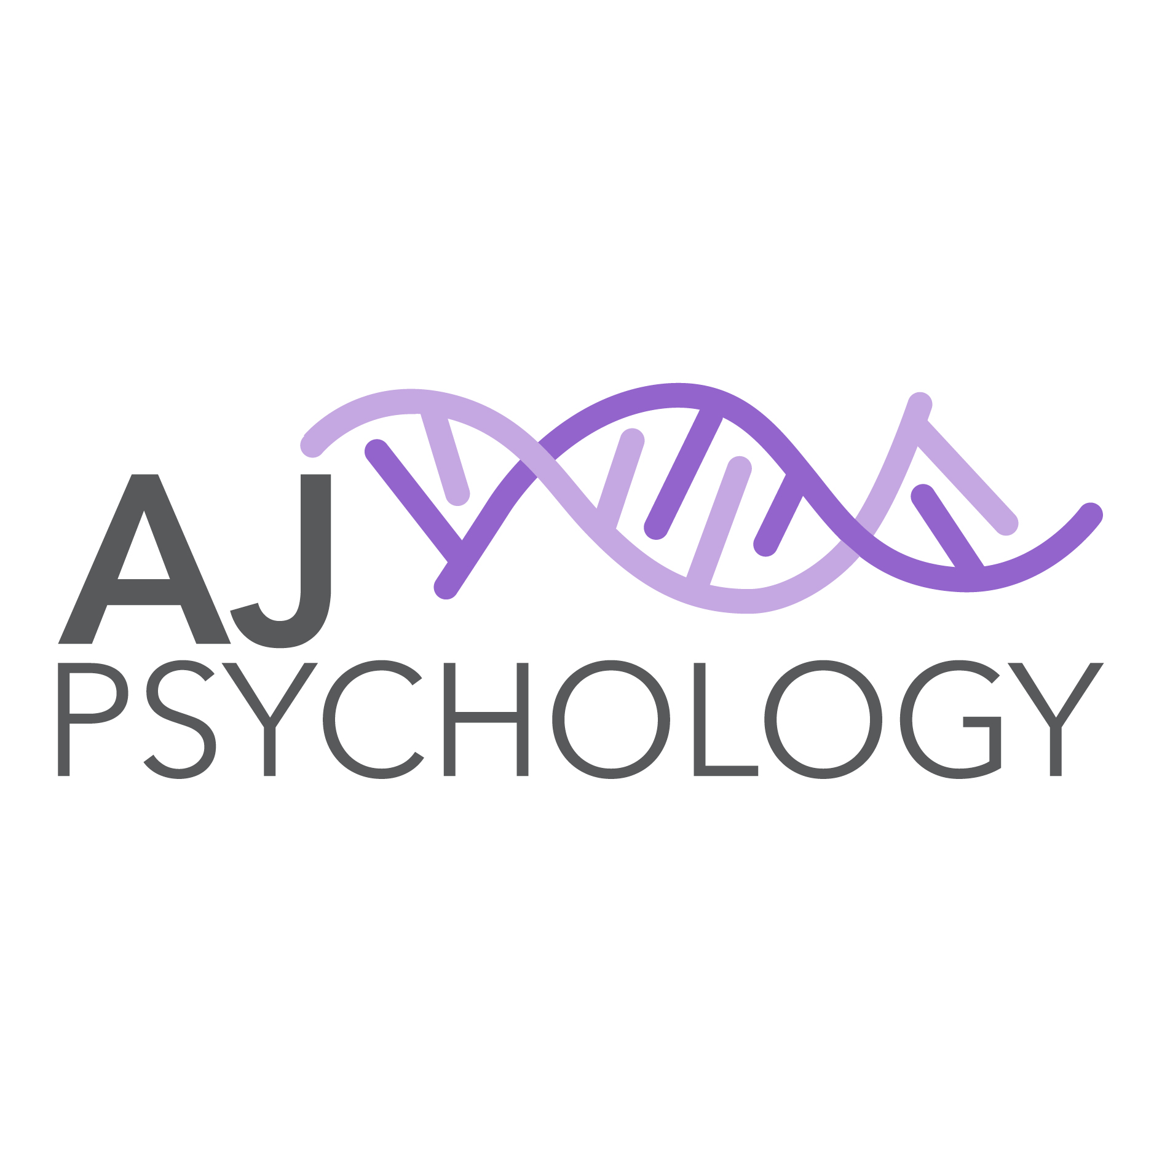
DRUMBEAT is the world’s leading therapeutic drumming program supported by independent research and evaluations – focusing on building resilience through rhythm.
- Increased mental wellbeing
- Increased knowledge and understanding of relationship issues
- Reduction in psychological distress
- Reduction in antisocial behaviour
- Reduction in school absenteeism
- Reduction in reportable school based beahvioural incidences
- Improved self-regulation
- Increased social and emotional learning
- Increased empathy

Proven outcomes:

Holyoake’s DRUMBEAT program is based on research that identifies key issues related to health and social outcomes. It incorporates recent development in neurological research which notes the beneficial impact of rhythmic interventions on primal brain systems associated with anxiety and emotional control.
Wednesdays 5pm-6pm, 27th April – 29th June 2022
Weekly Group Sessions (10 one hour sessions)
Facilitators: Dr Jo Winther (Clinical Psychologist) and Josh Winther (Psychology/Criminology Student) see
https://ajpsychology00.wixsite.com/ajpsychology/about-us
Location: Winhaven Animal Assisted Therapy, Sunbury (rural property)
Cost: $500 for 10 sessions
(medicare group rebate available if eligible; NDIS invoicing also available if eligible)
RSVP email only: ajpsychology00@gmail.com by 15th Apirl 2022 and you will be contacted to arrange an intake interview.
*Note: It is important for participants to attend all 10 sessions

Need more information about DRUMBEAT see:
Facebook www.facebook.com/HolyoakeDRUMBEAT
You Tube https://www.youtube.com/HolyoakeDRUMBEAT

